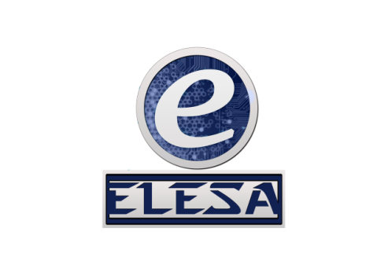

WALCHAND COLLEGE OF ENGINEERING, SANGLI

**ELESA**

**ELECTRONICS ENGINEERING STUDENTS’ ASSOCIATION**

Email: [walchand.elesa@gmail.com](mailto:walchand.elesa@gmail.com) Website: [www.elesa.in](http://www.elesa.in)

**Date:- 29/08/2018**

**SECRETARIAL REPORT ON**

**ARDUINO WORKSHOP**

This year ELESA organized 1 day Aurduino workshop for Third year Diploma students. Workshop was conducted on 28 th July 2018 from morning 8:00 a.m. to 6:00 p.m. Total 42 students registered and attended the workshop. Arduino is an open-source electronics platform based on easy-to-use hardware and software. Arduino boards are able to read inputs - light on a sensor, a finger on a button, or a Twitter message - and turn it into an output - activating a motor, turning on an LED, publishing something online. Over the years Arduino has been the brain of thousands of projects, from everyday objects to complex scientific instruments. We ln

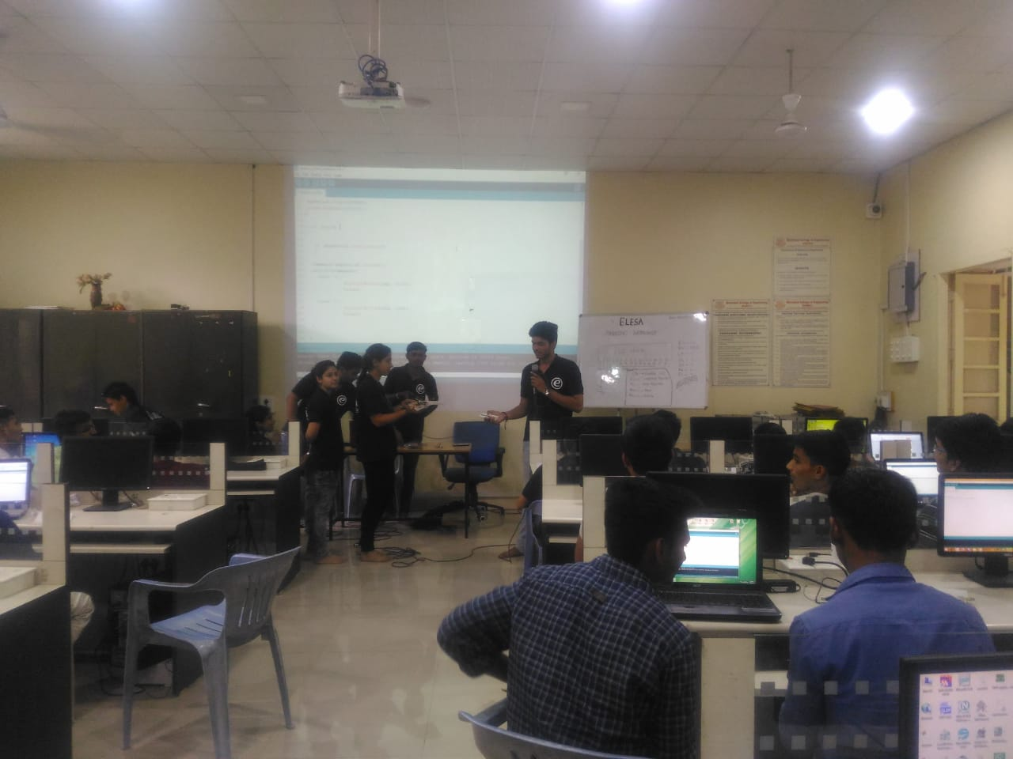

**Workshop Outline**

|  |  |  |
| --- | --- | --- |
| Sr. No | Session | Time |
| 1 | Introduction | 9:00 AM to 9:45 AM |
| 2 | LED interfacing | 9:45 AM to 10:45AM |
| Refreshment break 1 | | |
| 3 | Servo and DC motor interfacing | 11:00AM to 12:00 PM |
| 4 | Potentiometer interfacing | 12:00 PM to 1:00 PM |
| Lunch break | | |
| 5 | LCD | 2:00 PM to 3:00 PM |
| 6 | Relay interfacing | 3:00 PM to 4:00 PM |
| Refreshment break 1 | | |
| 7 | Bluetooth interfacing | 4:15PM to 4:45 PM |
| 8 | MIT Appinventer application development | 4:45 PM to 5:30 PM |

**Budget**

Amount collected: 100 X 42 = 4200

Expenses

|  |  |  |
| --- | --- | --- |
| Sr. No | Particular | ammount |
| 1 | Certificate | 12 x 45 = 540 |
| 2 | Poster | 20 x 3 = 60 |
| 3 | Pen | 3 x 45 = 135 |
| 4 | Notepad | 5 x 45= 225 |
| 5 | Refreshment | 55 x 25=1375 |
| Total | | 2335 |

Net profit: 4200-2335=1665

List of participants:



Poster:

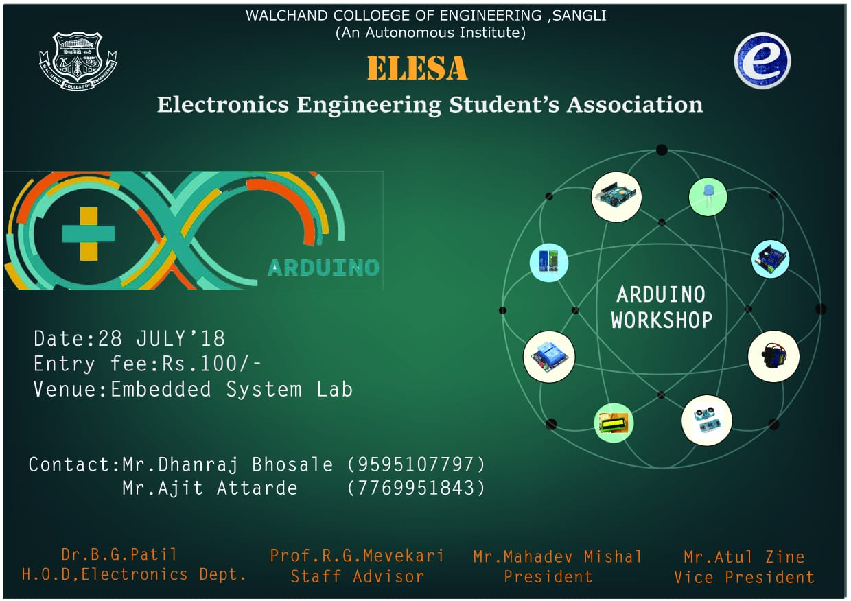

Certificate

